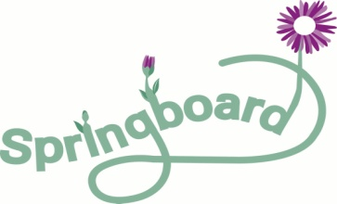
Parents Plus – Parenting When Separated Programme

A practical and positive evidence-based course for parents who are preparing for, going through or have gone through a separation or divorce.

Parenting when separated can be challenging and confusing. Drawing on international long-term evidence, the Parenting when Separated Programme is a six week course that highlights practical steps parents can take to help their children cope and thrive, as well as coping successfully themselves.

Topics include:
- Solving co-parenting problems in a positive way that focuses on the needs of children.
- Cope with the emotional impact of separation and learn stress management techniques.
- Help your children cope with the impact of the separation both emotionally and practically.
- Enhance communication with their children and with their children's other parent.
The ‘Parenting When Separated’ course does not propose to find magic answers but hopes to help parents to gain the support of other parents who may have similar experiences and to find down-to-earth solutions for difficult situations. The focus of the course is positive and aims to build on your strengths as a parent and what you are already doing right.

Who is it for?
This course is free to attend and is open to separated parents from all backgrounds. All mothers and Fathers are welcome, parents who live in the family home and parents who do not.
Both parents of the same children are welcome and encouraged to attend though we recommend you attend separate groups. Please contact to discuss this. We will meet all parents for an introductory meeting prior to the group starting.

Course Details
This course is run by two Social Workers in Springboard Family Support Project, Loughlinstown. The course is run over 6 weeks for approximately 2 hours per week.

Where is it on?
Springboard Family Support Project, based in St. Columbanus National School, Loughlinstown Drive, Loughlinstown, Co. Dublin.

When?
10.30 – 12.30 Tuesday 9th November- Tuesday 14th December 2021

What do I do next?
If you are interested in attending the course please call or email Caroline or Rachel on 01 2814934 or email caroline.jordan2@tusla.ie

